**A/ Pixracer basic views**

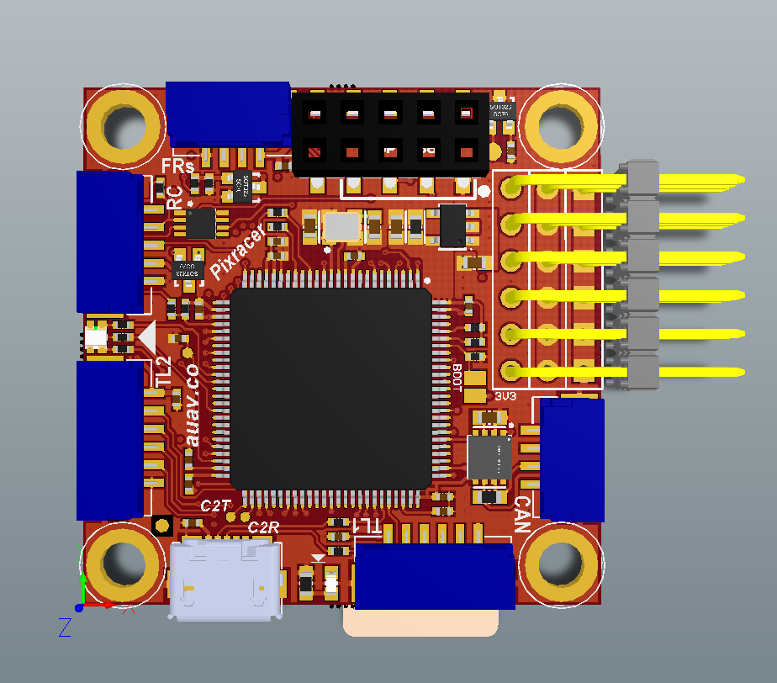

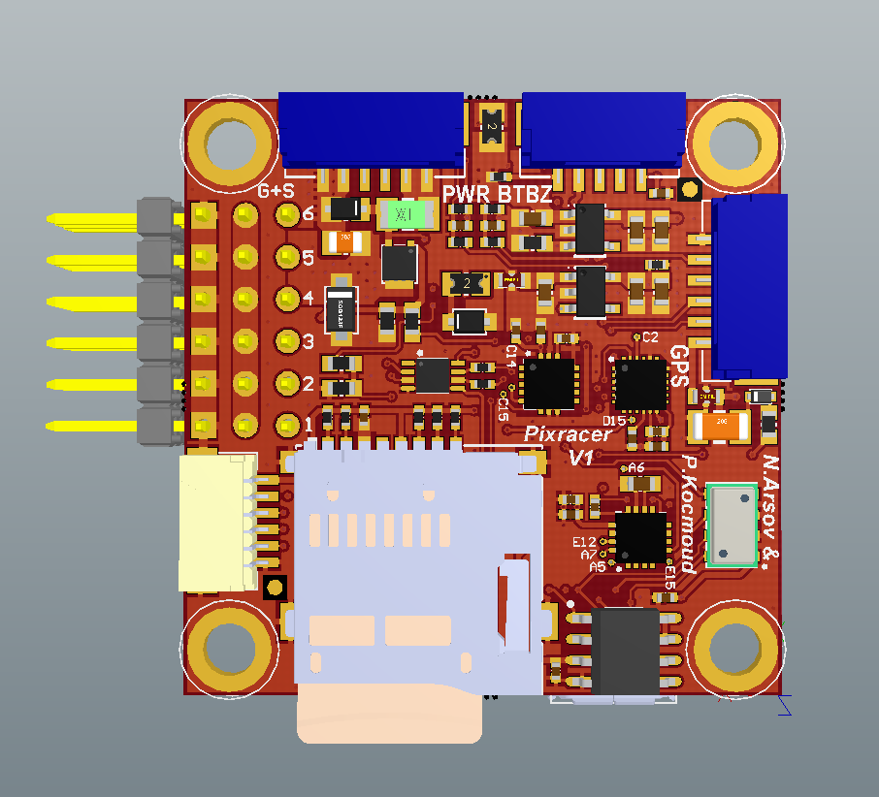

**TOP CONNECTORS**

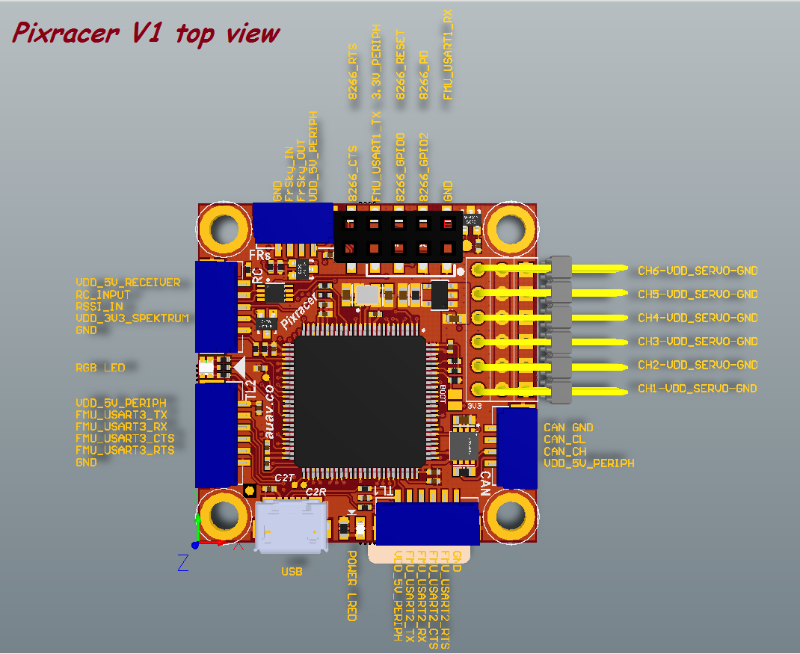

**BOTTOM CONNECTORS**

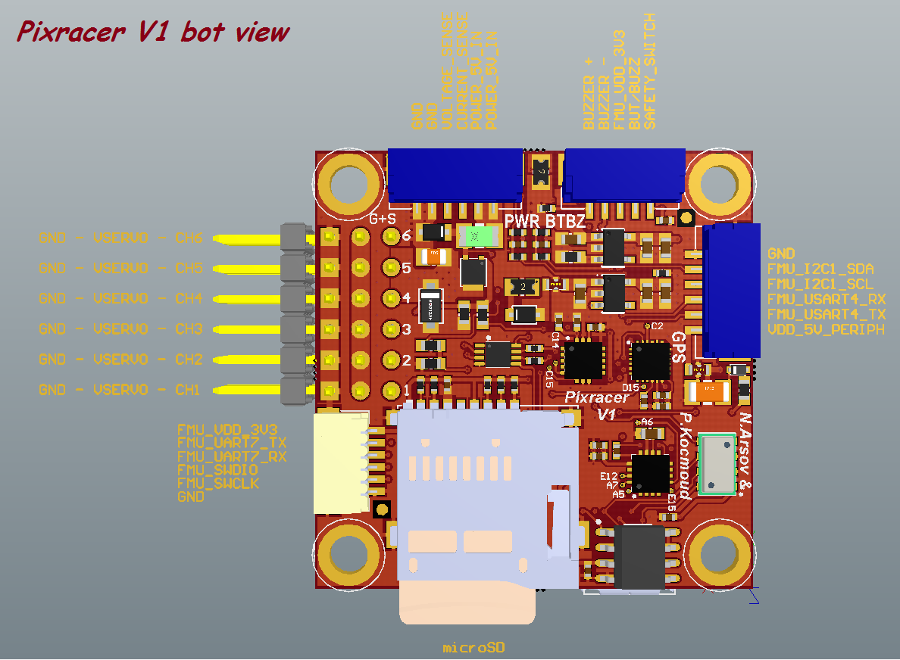

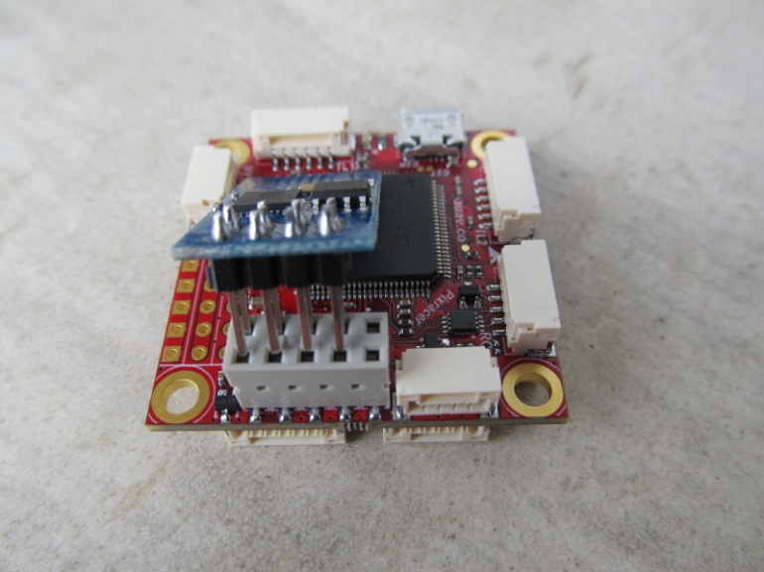 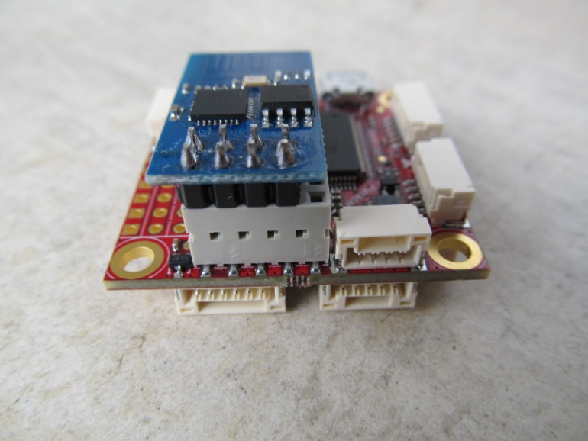

1. **TOP CONNECTORS**

**a/ FRs ( FrSky connector )**

1. VDD_5V_PERIPH
2. FrSky_OUT
3. FrSky_IN
4. GND

**b/ RC ( Receiver connector )**

1. VDD_5V_RECEIVER
2. RC_INPUT ( PPM, SPEKTRUM, SBus )
3. RSSI_IN
4. VDD_3V3_SPEKTRUM
5. GND

**c/ TL2 ( Telemetry 2 connector )**

1. VDD_5V_PERIPH
2. FMU_USART3_TxD
3. FMU_USART3_RxD
4. FMU_USART3_CTS
5. FMU_USART3_RTS
6. GND

**d/ USB**

USB connector

**e/ TL1 ( Telemetry 1 connector )**

1. VDD_5V_PERIPH
2. FMU_USART2_TxD
3. FMU_USART2_RxD
4. FMU_USART2_CTS
5. FMU_USART2_RTS
6. GND

**f/ SERVO CHANNELS**

CH1 – CH6 are the servo channels.

**NOTE! The VDD_SERVO rail is NOT connected to the Pixracer power!**

**Servos require their own 5V BEC!**

**g/ ESP8266 INTERFACE**

1. FMU_USART1_RxD
2. GND
3. ESP8266_PD ( power down )
4. ESP8266_GPIO2
5. ESP8266_RESET
6. ESP8266_GPIO0
7. VDD_3V3_PERIPH
8. FMU_USART1_TxD
9. ESP8266_RTS ( not implemented on ESP-01 module )
10. ESP8266_CTS ( not implemented on ESP-01 module )

**Pins marked with RED cross are for future use. Do not connect ESP-01 there!**

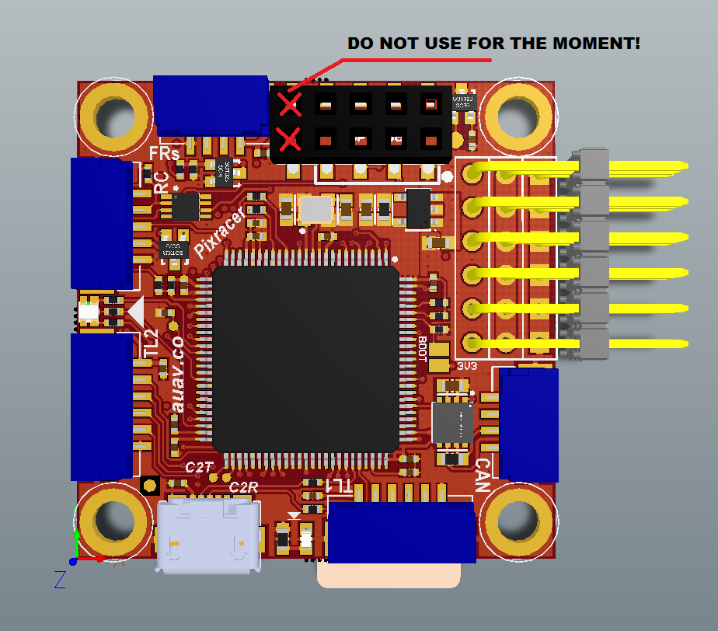

1. **BOTTOM CONNECTORS**

**a/ DEBUG CONNECTOR**

1. FMU_VDD_3V3
2. FMU_UART7_TxD
3. FMU_UART7_RxD
4. FMU_SWDIO
5. FMU_SWCLK
6. GND

**b/ PWR ( Power ) CONNECTOR**

1. POWER_5V_IN
2. POWER_5V_IN
3. CURRENT_SENSE
4. VOLTAGE_SENSE
5. GND
6. GND

**NOTE! PWR ( POWER SUPPLY) must be between 5.0VDC and 5.5VDC !**

**Voltages from VOLTAGE and CURRENT sensing should be 3.3VDC max!**

**c/ BTBZ ( buzzer / button connector )**

1. SAFETY_SWITCH
2. BUT/BUZZ ( button and buzzer common )
3. FMU_VDD_3V3
4. BUZZER –
5. BUZZER +

**d/ GPS ( GPS connector )**

1. VDD_5V_PERIPH
2. FMU_USART4_TxD
3. FMU_USART4_RxD
4. FMU_I2C1_SCL ( 3.3V tolerant )
5. FMU_I2C1_SDA ( 3.3V tolerant )
6. GND
7. **JTAG**

The JTAG interface is implemented on a JST SM06B-SRSS 1mm pitch connector.

Very useful device for debugging is the Black Sphere Debugger (<http://www.tag-connect.com/BLACK-SPHERE-DBG> ).

For flashing the bootloader, firmware and debugging, the cheap STM32 Nucleo or STM LINK-V2 boards can be used (<http://mbed.org/platforms/?tvend=10> ).

The Pixracer V1 board is supplied with FMU bootloader flashed, so one doesn’t need to flash it again.

1. **LEDS and SAFETY SWITCH**

There are 2 LEDs on the Pixracer V1 board –Power LED ( GREEN ) and RGB status LED.

**LED STATUS TABLE**

GREEN = Power LED = always ON

**SAFETY SWITCH STATUS**

ON = FMU ARMED

SLOW BLINK = Ready to arm

FAST BLINK = Error / Refusing to arm

1. **POWERING Pixracer V1**

There are two power inputs – USB ( only for programming and testing ) and Power from the Power connector.

**NOTE! The Power must be between 5.0VDC to 5.5VDC!**

**The VDD_SERVO rail is NOT connected to the Pixracer power!**

**VERY IMPORTANT NOTE!**

**THE MAX ALLOWABLE TOTAL CURRENT CONSUMPTION FOR ALL PERIPHERALS IS 1A! Don’t connect the VCC of servos or High Power Telemetry/OSD modules.**